CCA Members – How to Lobby Your Local MP
This tutorial provides a quick, 6-step process for contacting your local MP for the federal government.
- Go to https://www.ourcommons.ca/members/en
- In the search bar under FIND MEMBERS OF PARLIAMENT enter your postal code and click the ‘search’ icon – the MP’s info should appear

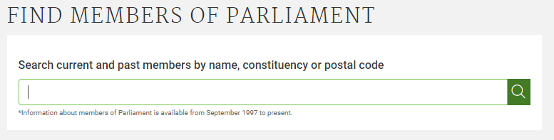

- Click on the MP’s name – this will take you to their page which will have their picture and the following information
  - Their first and last name
  - Their political affiliation
  - Their constituency
  - The province they are based in
  - Their preferred language

- Click the ‘Contact’ tab to see their details – their email should be available
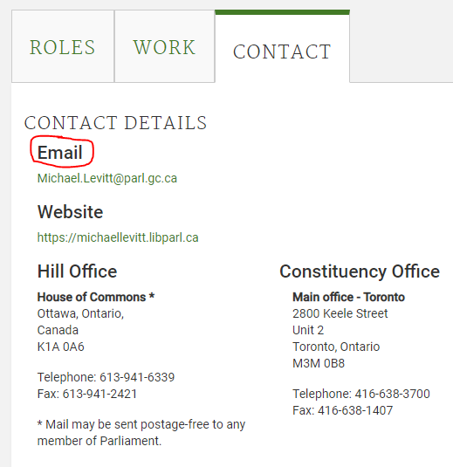

- Using their email link, draft them a note advocating for whatever issue you want brought to their attention.
  - The note should include that you are a constituent, be to the point, firm and direct. Do not worry about it being lengthy, use your own words – this will come across as authentic.
  - Ask that they follow up with you, e.g. “I look forward to hearing from you on this matter.”

- CC the address provided by Canadian Camping Association, so it is clear you are working in conjunction with them.

Success! You have just lobbied your federal MP and brought something to their attention

